Phonons in aluminium
William O’Brien, University College London, February 2016.
Some simple simulation work to investigate the influence of phonons in solid (crystalline) aluminium has been carried out and is discussed in this report. The simulation program used was VASP (Vienna Ab Initio Simulation Package). VASP uses density functional theory to create a pseudo-potential due to the atoms in the crystal.
In the first exercise, the equilibrium volume of Wigner-Seitz cell of aluminium at absolute zero within a crystal lattice was determined. VASP was run a number of times using alternative ‘k-point’ values (a measure of the sampling point density in k-space) to gain an impression as to how these values affects the precision of the determined equilibrium volume. The answer obtained was 15.875 ± 0.001 Å³. A distribution for the energy as a function of volume was generated, using k-points values of 18 × 18 × 18.
In the second exercise, phonon dispersion relations were computed using different values for the super cell size and k-point values. Of the combinations tried, the one which produced distributions that were most consistent with experimentally deduced values had a super cell size of 4 × 4 × 4 and k-point values of 4 × 4 × 4.
In the final exercise, the Helmholtz free energy of aluminium was calculated at a range of temperatures between 0 K and 900 K and a range of Wigner-Seitz cell volumes. From the values obtained, it was possible to deduce the equilibrium volume of aluminium at each temperature. By plotting the equilibrium volume against temperature it was possible to estimate the volumetric and linear coefficients of thermal expansion. The value of the linear coefficient obtained at 300 K was
22.0 μm/m.K, which is very close to the true value.
The crystalline structure of aluminium is discussed in section 1. Some basic physical principles related to lattice vibrations in a solid and the concept of phonons are discussed in section 2. The method and results obtained related to the three aforementioned exercises are discussed in sections 3, 4 and 5 respectively.

Crystalline structure of aluminium
Under normal conditions, aluminium adopts a face-centred cubic structure. The unit cell of a face-centred cubic structure as a cube shown in figure 1a. The crystal lattice is constructed by stacking unit cell is together along each direction. Each cell contains four atoms (6 × ½ + 8 × ¹/₈). It is a compact structure and, if the atoms are regarded as identical perfect spheres, contains just 26% empty space [1]. The structure is isotropic, meaning a single crystal’s properties are identical when measured along orthogonal directions. The height of the unit cell is known as the lattice parameter. Figure 1b shows the same structure but with the atoms drawn smaller, making it is easier to visualise the relative positions of the atoms.
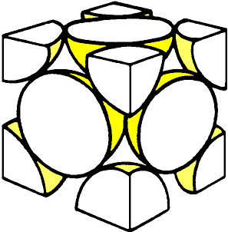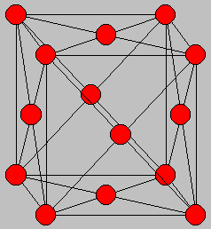
a)
b)
Lattice parameter
Figure 1 The unit cell the face-centred cubic structure.
The crystal structure can be created in a similar manner by just taking one atom and three of its nearest neighbours, as shown in figure 2. This unit cell is known as the primitive cell. This primitive cell contains three lattice vectors, (0.5a, 0, 0.5a), (0.5a, 0.5a, 0) & (0, 0.5a, 0.5a) where a is the lattice parameter.
b)
a)

(0.5a, 0,5a, 0)
(0.5a, 0, 0.5a)
(0, 0.5a, 0.5a)
a

Figure 2 a) The primitive cell of the face-centred cubic structure with the three lattice vectors marked. b) the primitive cell is repeated in three-dimensions is to form the crystal.
The unit cell of the crystal can also be represented by the Wigner-Seitz cell. It contains one atom and all space that is closer to that atom then to any other (i.e. the space that atom effectively occupies). The Wigner-Seitz for a face-centred cubic structure is shown in figure 3. The Wigner-Seitz cell is equivalent to the first Brillouin zone of the crystal in reciprocal space.
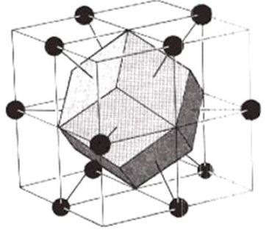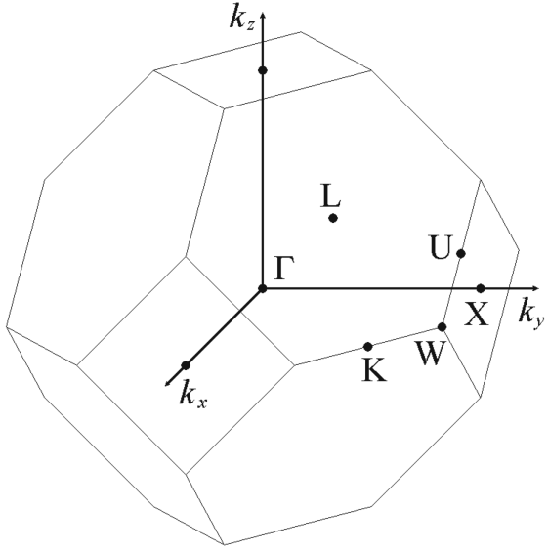
a)
b)
Figure 3 a) The shaded volume represents the Wigner-Seitz cell of the face-centred cubic structure. b) The Wigner-Seitz cell in reciprocal space is the first Brillouin zone. The origin is denoted by Γ. L, X, U, K and W mark other points of symmetry within the zone [2].

Lattice vibrations

Simple harmonic motion of atoms
Consider a scenario in which two like atoms of a noble element, such as argon, are at absolute zero and separated from each other by distance that is comparatively large compared to their diameters. These atoms experience a weak mutual attractive force, known as the Van de Waal’s force, resulting from mutually induced dipoles. This attractive force increases in magnitude as the atoms are moved closer together. However, if these atoms are moved too close together, to the point where their atomic orbitals overlap, the Pauli Exclusion Principle intervenes and the atoms feel a strong repulsive force. The resulting potential, V, that each atom experiences can be approximated by the Lennard-Jones potential
$$V(r)= V_{0}\left\{{\left(\frac{r}{r_{0}}\right)}^{-12}{-2\left(\frac{r}{r_{0}}\right)}^{-6}\right\}$$
where r₀ marks the point at which the potential is a minimum and V₀ with the potential at that point [3].
The fact that a minimum exists means that it is possible form a bound state between two noble element atoms at low temperatures. The potential function can be expressed as a Taylor expansion about the minimum point, r₀,
$$V\left(r\right)= V_{0}\left\{-1+{241\left(r-r_{0}\right)}^{2}+ …\right\}.$$
If r – r₀ is very much smaller than the width of the potential well, the higher-order terms can be disregarded, leaving a parabolic distribution about r₀.

Figure 4 Lennard-Jones potential for noble gas atoms function of atomic separation.
If the two atoms are initially at rest and positioned separation r₀ then one is moved away from the other through a small distance A. That atom will experience a restoring force that tries to return it to its equilibrium position. The magnitude of the restoring force is equal to the potential gradient. In a quadratic potential well, the magnitude of the restoring force, F, will be proportional to A. One can write
F = -KA
where K is the constant of proportionality. This is the condition the simple harmonic motion. The system becomes analogous to masses attached by spring and K is the force constant of the spring. Provided that A is kept small, the natural frequency of oscillation is independent of A. The natural angular frequency of oscillation, ω₀, which is 2π divided by the cycle frequency is given by the equation
$${}_{0}=\sqrt{\frac{2K}{m}}$$
where m is the mass of each atom.
The author chose to discuss the mutual forces between two noble gas atoms as it is easy to write down a good approximation of the potential as a function of distance. The potential curves are more complicated in situations where alternative forms of bonding exist, but the principles regarding harmonic motion are the same as long as the displacements are sufficiently small.
When atoms of metallic element, such as aluminium, are moved into close proximity, the energy levels of the outer (valence) electrons become less well-defined. When a large number of such atoms are brought into close proximity to form a crystal, these electrons become delocalised and their wave functions can extend right through the crystal. These delocalised electrons is the reason why the metals generally have high electrical and thermal conductivities. When the atoms were separated, de Broglie wavelength of the valence electrons can be no larger than the circumference of the atom. Once delocalised, the Broglie wavelengths of these electrons can become very much larger. As a result, the average kinetic energy of these electrons is reduced. This reduction in kinetic energy is converted into binding energy that holds the structure together. This is metallic bonding [1].

A one-dimensional crystal
Let is now imagine a chain of N identical atoms which equally spaced from each other and whose bonds are represented by identical springs with spring constant, K (see figure 5). If a designated atom, labelled ‘n’ is displaced from its equilibrium position through a distance A, it will experience restoring forces due to the compression and rarefaction of the neighbouring springs and gains elastic potential energy (= Kx²). That energy is then released along the chain of atoms.

n +1
n -1
n

a
A
u_{n}
Figure 5 A chain of identical atoms bound by identical springs. If one atom is displaced through a small distance and then released, travelling waves and directed longitudinally chain in both directions.

The equation of motion of atom n is
$$m\frac{d^{2}u_{n}(t)}{{dt}^{2}}-K\left\{u_{n+1}-2u_{n}{+ u}_{n-1}\right\}=0$$
where u_{n} is the distance from the first atom in the chain. It can be written in terms of the atomic spacing, a,
$$m\frac{d^{2}\left(na\right)}{{dx}^{2}}-K\left\{\left(n+1\right)a+\left(n-1\right)a-2(na+A)\right\}=0 .$$
This simplifies to
$$m\frac{d^{2}(na)}{{dx}^{2}}+2AK=0 .$$
The solutions are travelling waves of the form
$$u_{n}=Ae^{i(qna- t)}$$
where q is the wave number (= 2π divided by the wavelength). It follows that
$$=\sqrt{\frac{K}{m}} \left|\sin{\frac{qa}{2}}\right|.$$
This is an example of a dispersion relation [1]. By imposing a boundary condition, u_{n} = u_{N+n} it follows that
$$q=\frac{2πn}{Na}$$
Setting this boundary condition is equivalent to attaching the ends of the chain together to form a ring. When there were just two atoms bonded together there was just one natural frequency of oscillation. In this situation there is a range of permitted frequencies. Figure 6 shows a dispersion relation for a one-dimensional crystal. The points mark the normal mode frequencies for a chain of 20 atoms. If N is very large, as is the case in a macroscopic crystal, the curve becomes continuous. The wave number range, between q = -π/a and q = +π/a marks the first Brillouin zone in this one-dimensional crystal. The gradient of the dispersion relation, dω/dk is the group velocity. This means that the lowest frequency modes in the crystal transmit energy faster than do the higher frequency modes.
When one considers a three-dimensional crystal of like atoms, the situation is very much more complicated. When one atom is displaced and released, energy is transmitted not just in the longitudinal direction (parallel to the direction of displacement) but in the transverse directions as well, these transverse modes have different dispersion relations to the longitudinal modes. The dispersion relations for these modes have to be computed by numerical methods.

$$\sqrt{\frac{K}{m}}$$
Figure 6 the dispersion relation for a hypothetical one-dimensional crystal, consisting of a chain of identical atoms. The points mark the permitted mode frequencies when N, the number of atoms, equals 20. The n/N for some of the modes have been included.

Phonons
In quantum mechanics, atomic motions are governed by the Schrödinger equation. The time-independent Schrödinger equation for a particle of mass m within a one-dimensional parabolic potential well is
$$-\frac{ℏ^{2}}{2m}\frac{d^{2}Ψ(x)}{{dx}^{2}}+ \frac{1}{2}m{{}_{n}}^{2}x^{2}Ψ(x)=E_{n}Ψ(x)$$
where Ψ(x) is the wavefunction, $ℏ$ is Planck’s factor (h/2π) and E_{n} is the energy [4]. |Ψ(x)²| gives the probability density function (the probability of finding the particle between position x and x + dx when a making a measurement). The equation has an infinite number of solutions. The four lowest energy solutions and their associated energy eigenvalues are displayed in figure 7.
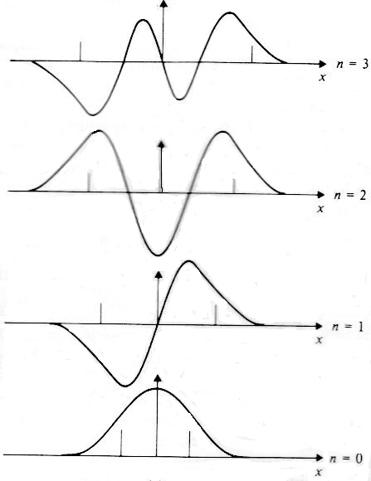

$$Ψ_{3}(x)={\left(\frac{1}{9π}\right)}^{1/4}{\left(\frac{m{{}_{n}}^{2}}{ℏ}\right)}^{3/4}\left(\frac{2m{}_{n}}{ℏ}x^{3}-x\right)\exp\left(-\frac{m{}_{n}x^{2}}{2ℏ}\right) E_{3}= \frac{7}{2}ℏω$$

$$Ψ_{2}\left(x\right)={\left(\frac{m{{}_{n}}^{2}}{4πℏ}\right)}^{1/4}\left(\frac{2m{}_{n}}{ℏ}x^{2}-1\right)\exp\left(-\frac{m{}_{n}x^{2}}{2ℏ}\right) E_{2}= \frac{5}{2}ℏω$$
$$Ψ_{1}\left(x\right)={\left(\frac{4}{π}\right)}^{1/4}{\left(\frac{m{}_{n}}{ℏ}\right)}^{3/4}x\exp\left(-\frac{m{}_{n}x^{2}}{2ℏ}\right) E_{1}= \frac{3}{2}ℏω$$
$$Ψ_{0}\left(x\right)={\left(\frac{m{}_{n}}{πℏ}\right)}^{1/4}\exp\left(-\frac{m{}_{n}x^{2}}{2ℏ}\right) E_{0}= \frac{1}{2}ℏω$$
Figure 7 The four lowest energy solutions to the Schrödinger equation for the one-dimensional quantum harmonic oscillator and their corresponding energy eigenvalues.
The result of interest here is that energy of a quantum mechanical harmonic oscillator is quantised. The permitted values, E_{n}, are given by
$E_{n}=(n + ½)ℏω$ (1)
where n is a positive integer. The energy eigenvalue corresponding to n = 0, so $½ℏω$, is known as the zero point energy. This has to exist to comply with Heisenberg’s uncertainty principle.
In quantum mechanics, heat transfer within a solid material is carried out by phonons, quanta of vibrational energy. The lattice vibrations in a solid can be regarded as a phonon gas trapped in a box. Phonons are bosons with zero spin, which means that they cannot transfer angular momentum to other particles, and obey Bose-Einstein statistics. Unlike regular particles, phonons are not conserved; meaning that their number can change even in an isolated system.
The Helmholtz energy, F, in thermodynamics is defined by the equation
F = U - TS
where U is the internal energy, T is the temperature and S is the entropy of the system. The second law of thermodynamics states that the entropy of isolated macroscopic system must increase. If S increases, F decreases so, over time, such a system moves towards a state with a low Helmholtz free energy. In statistical mechanics, the Helmholtz free energy is a crucial parameter in the canonical ensemble, which describes an isolated system of particles in thermal equilibrium with an infinite heat bath [5]. It is defined, in terms of the internal partition function, Z,
F = -k T lnZ (2)
where k is Boltzmann’s constant. The internal partition function is a summation of the Boltzmann factors of all possible energy states
$$Z=\sum_{n=0}^{∞}{e^{-{E_{n}}/{kT}}}$$
where E_{n} is a particular energy state. In this instance, E_{n} is the phonon energy given by equation 1.
$$Z=\sum_{n=0}^{∞}{e^{-{(n + ½)ℏω}/{kT}}}$$
Substituting into equation 2, we obtain
$$F=-kT\ln\left\{\sum_{n=0}^{∞}{e^{-{(n + ½)ℏω}/{kT}}}\right\}$$
$$since\ln{e^{-{(n + ½)ℏω}/{kT}}}=-\ln{e^{{½ℏω}/{kT}}}- ln{e^{{nℏω}/{kT}}}$$
$$F=kT \ln{e^{{½ℏω}/{kT}}}-kT\ln\left\{\sum_{n=0}^{∞}{e^{{-nℏω}/{kT}}}\right\}$$
$$F=½ℏω-kT\ln\left\{\sum_{n=0}^{∞}{e^{{-nℏω}/{kT}}}\right\}$$
The summation is now a simple geometric series.
$$F=½ℏω-kT\ln\left\{\frac{1}{1-e^{{-ℏω}/{kT}}}\right\}$$
$$F=½ℏω+kT\ln\left\{1-e^{{-ℏω}/{kT}}\right\} (3)$$
The first term originates from zero point energy. Equation 3 can be rewritten,
$$F=kT\ln\left\{2 sinh\left(\frac{ℏω}{2kT}\right)\right\} \left(4\right).$$
At high temperatures, i.e. $kT≫ℏω$, equation 3 can be approximated to
$$F=kT\ln{ \left(\frac{ℏω}{kT}\right)}$$
The Helmholtz free energy of crystalline structure can be written as
$$F=E_{0}+F_{vib}\left(T\right) (5)$$
where E₀ is the minimum energy of the crystal (all atoms in their equilibrium positions at absolute zero) and F_{vib}(T) is the vibrational contribution to the free energy due to phonons. As was mentioned in section 2.2, only vibrational waves of certain frequencies can propagate through a crystal lattice. Hence only phonons of specific frequency propagate. If one uses the harmonic approximation, which disregards high order anharmonic terms,
$$F_{vib}(T)=kT\sum_{q}{\ln\left\{2\sinh\left(\frac{ℏω_{q}}{2kT}\right) \right\}} (6)$$
where ω_{q} is the angular frequency corresponding to a particular wave vector, q [6]. The summation is over all permitted wave vectors. In the classical limit, $kT≫ℏω$, equation 5 becomes
$$F_{vib}\left(T\right)=kT\sum_{q}{\ln\left(\frac{ℏω_{q}}{kT}\right)} \left(7\right).$$

The equilibrium volume of aluminium at absolute zero
The equilibrium volume of aluminium at absolute zero was calculated by running VASP for a single Wigner-Seitz cell. VASP uses density functional theory to create a pseudo-potential. It is a powerful tool for predicting the properties that materials possess in extreme conditions, such as the high temperatures and pressures that exist in planetary interiors, that might be very difficult or impossible to reproduce in experiment. Density functional theory is a quantum mechanically driven modelling method that uses functionals (functions of a function) to estimate the electron density. Because free (or ‘nearly free’) electrons are so much lighter than the ions in a metallic lattice, their wavefunctions are much broader. This increases the need for introducing quantum mechanics. The potential function that it calculates is often regarded as a pseudo-potential because it only takes into account the spatial positions of the valence (outer shell) electrons of the atoms. The core (closed shell) electrons are regarded as fixed.
VASP uses inputs defined in four files: POSCAR, INCAR, POTCAR and KPOINTS. Information regarding the pseudo-potential is contained in the file POTCAR. Information regarding the atomic masses, the primitive cell lattice vectors and the size of the “super cell” (discussed in section 4) is contained in the POSCAR file. The KPOINTS file contains a significant set of parameters, known as ‘k-points’.
There are three k-points values to set, one for each spatial dimension. Because the structure is isotropic, these values were always made equal to each other. The
k-points values determine how many sampling points along each orthogonal direction between each atom in reciprocal space are used to evaluate the pseudo-potential. Increasing the k-points number improves the accuracy of the result but also increases the computation time.
Simulation was run using k-points values between 4 × 4 × 4 and 30 × 30 × 30. The results are shown in figure 8. For the plotted k-points values of 16 or greater, there was only a 0.03% total spread. The equilibrium volume was taken to be 15.875 ± 0.001 Å³. This is the mean of the values calculated when the highest number of k-points were used. The error is the standard error on these points (the standard deviation divided by the square root on the number of samples).

Figure 8 The equilibrium volume of a Wigner Seitz cell of aluminium as a function ‘k-points’ (number of sampling points along each spatial dimension).
After obtaining this result, a distribution for the energy as a function of volume was generated by running VASP several times at different Wigner-Seitz cell volumes. The k-points values were set to 18 × 18 × 18. A script was written to rerun VASP automatically, with a preset range of volumes. This was done to obtain a lattice energy vs. energy distribution.

Phonon dispersion curves
In the second exercise, phonon dispersion curves of aluminium were produced. In order to achieve this, the first step was to construct a “super cell”. A super cell consists of a set of interconnected the Wigner-Seitz cells, or Brillouin zones when converted to k-space. The first super cell created was a 2 × 2 × 2 super cell. Such a super cell contains eight atoms. The volume of the super cell was set to 127 Å³ (8 × 15.875 Å³, the equilibrium volume deduced in section 3). The program phon was used to create a file called SPOSCAR. phon is a multi-functional program written by Dario Alfè and described in [6]. The generated SPOSCAR file includes information about the super cell: the number of atoms within in, its volume and the equilibrium coordinates of all its atoms. The contents of this file were copied into the POSCAR file, so that VASP can make use of the information.
The second step was to produce a force constant matrix. This was done using a program called runphon. This program shifts the location of atom #1, whose equilibrium position was set to be at the origin (0, 0, 0). The forces that it experiences due to all the other atoms in the super cell are then calculated. The magnitude and direction of the displacement can be adjusted. The magnitude was set to 0.04Å and included components in three orthogonal directions so that it excites as many modes as possible. This step can be time-consuming, particularly if a large super cell has been constructed.
Once the force constant matrix had been generated, the phonon frequencies can be calculated. This was done by running the phon program. The program creates a dynamical matrix, which is the Fourier transform of the force constant matrix. It then diagonalises the dynamical matrix to find the eigenvalues, which are equal to the squares of phonon frequencies. With the default settings, defined in the file INPHON, the program calculates 51 frequencies along three designated directions in reciprocal space. Three lines are used to determine these three directions. One lines goes from point Γ to point X, the second from point K to point Γ and the third from point Γ to point L (see figure 1b).
Simulations were carried out using a 2 × 2 × 2 super cell and a range of k-points values. The dispersion relations that resulted are shown in figure 9, plots a to e. The solid lines are the dispersion relations deduced by simulation. The points represent frequencies determined by experiment (same data shown on each graph). The experimental values are the result neutron spectroscopy work performed by Stedman and Nilsson [6]. Clearly, the agreement between simulation and experiment is quite poor when k-points values of just were 2 × 2 × 2 used. However, the agreement is a lot better when k-points values increased to 4 × 4 × 4. Increasing the k-points values offers further improvement, but there is little difference between the dispersion relations calculated when k-points values of 24 × 24 × 24 compared to when values of 12 × 12 × 12 were used.
Further simulations were carried out, but this time with a 4 × 4 × 4 super cell. The volume of the super cell was set to 1016 Å³ (64 × 15.875 Å³). The size the super cell increases the accuracy of the simulation because the influence due to a larger number of atoms is taken into account. In any material, the atoms feel forces due to not just the nearest neighbouring atoms but also those slightly further away. The cost of increasing the size of the super cell is increased computation time. That can be a problem when doing a large number of simulations. In metals, the magnitude of force constant vector normally falls off more quickly with distance than it does with other types of material (such as ionically-bonded substances). So constructing an enormous super cell is not normally necessary. Having said that, a high k-point density is usually needed when simulating metals due to the delocalised nature of the valence electrons. A 4 × 4 × 4 super cell contains eight times as many atoms as does a 2 × 2 × 2 super cell. However, when the dimensions of the super cell are doubled, the atomic spacing in reciprocal space is halved. This means we can halve the k-points values to achieve the same sampling point density that we had previously. In other words, using a 4 × 4 × 4 super cell with k-points set to 1 × 1 × 1 is equivalent to using a 2 × 2 × 2 super cell with k-points set to 2 × 2 × 2 in terms of sampling point density.
The dispersion relations obtained when using a 4 × 4 × 4 super cell was used is shown in figure 9, plots f to h. With k-points set to 1 × 1 × 1, the agreement with experiment is very poor. However, the result is a lot better when k-points was set to 2 × 2 × 2. When k-points was set to 4 × 4 × 4, the agreement with the experimental values is more consistent than it was with any other combination tried.
To see how the magnitude of the initial atomic displacement affects the calculated frequencies, further simulations were carried out with displacements set to 0.008 Å, 0.04 Å and 0.4 Å. The resulting dispersion curves are shown in figure 10. To produce these, a 4 × 4 × 4 super cell was used k-points was set to 4 × 4 × 4. The graph in figure 10b is identical to that in figure 9h. There is very little difference between the curves produced displacement was 0.008 Å compared to when it was 0.04 Å. However, when the displacement was increased 0.4 Å, significant discrepancies result. When too a large displacement is used, it is not possible to approximate the potential well to a parabola.

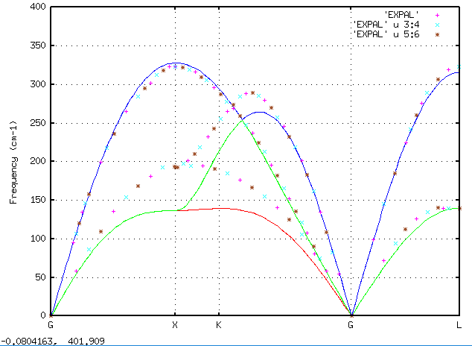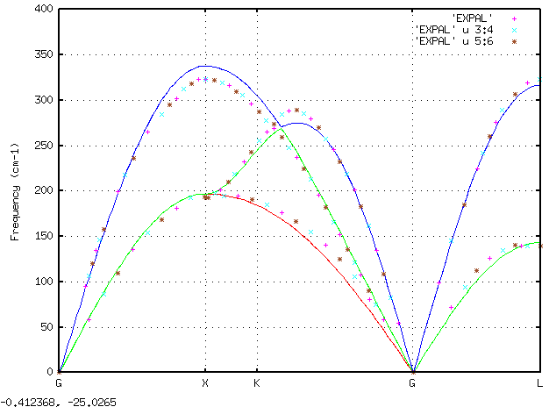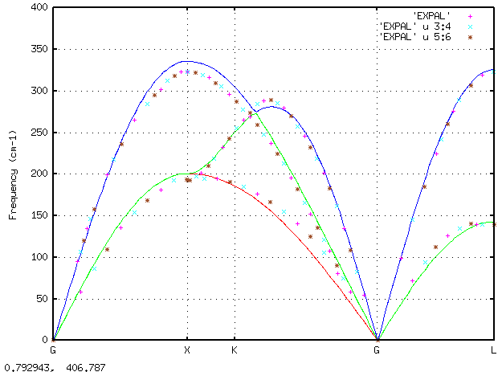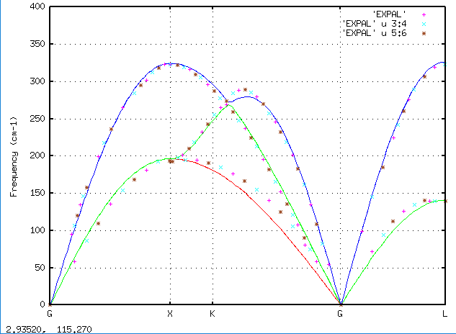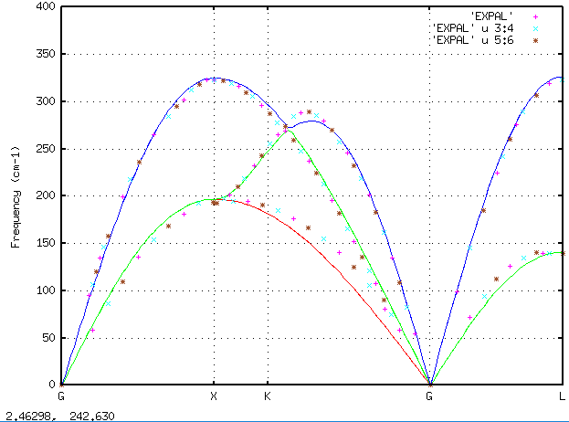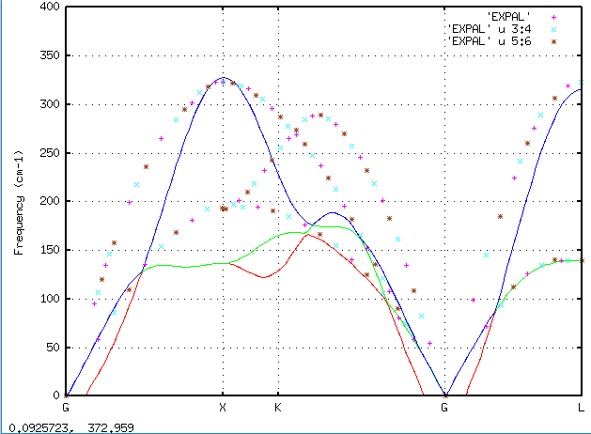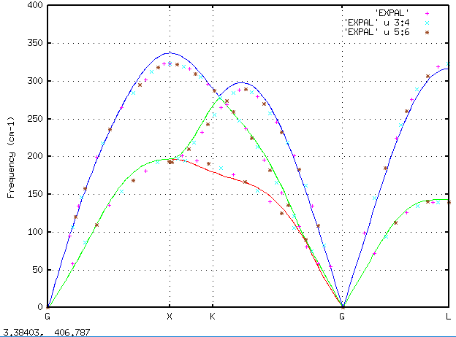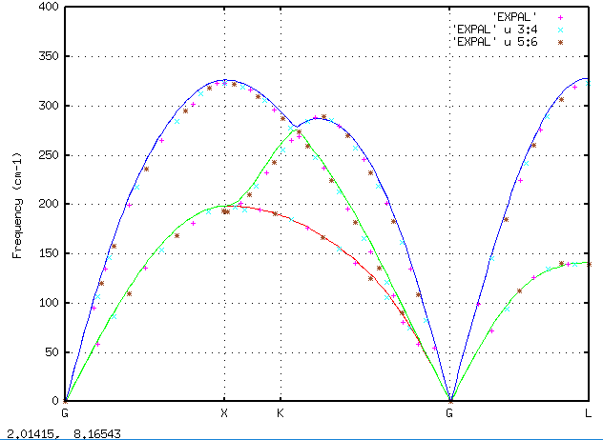
b) Super cell 2 × 2 × 2 k-points 4 × 4 × 4
a) Super cell 2 × 2 × 2 k-points 2 × 2 × 2
c) Super cell 2 × 2 × 2 k-points 6 × 6 × 6
d) Super cell 2 × 2 × 2 k-points 12 × 12 × 12
e) Super cell 2 × 2 × 2 k-points 24 × 24 × 24
g) Super cell 4 × 4 × 4 k-points 2 × 2 × 2
f) Super cell 4 × 4 × 4 k-points 1 × 1 × 1
h) Super cell 4 × 4 × 4 k-points 4 × 4 × 4
Figure 9 Phonon dispersion relations for aluminium with differently sized super cells and different k-points values. The solid lines represent results from simulations discussed here. The points represent experimentally deduced values. The displacement was 0.04 Å in each case. The abcissae letters (G, X, K & L) refer to specific points where symmetry exists within the Brillouin zone (see figure 1b). G refers to point Γ, the origin.
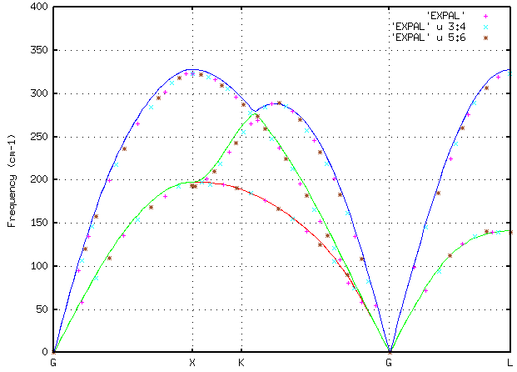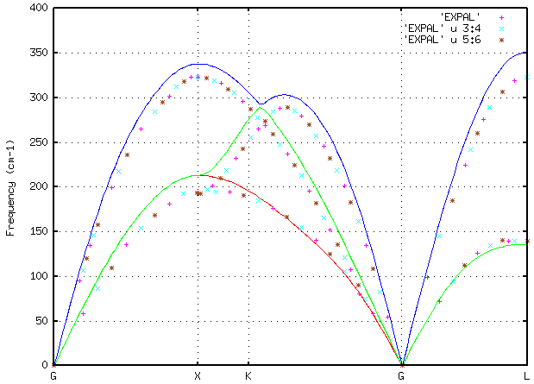
a)
b)
c)
Super cell 4 × 4 × 4, k-points 4 × 4 × 4, displacement = 0.4 Å
Super cell 4 × 4 × 4, k-points 4 × 4 × 4, displacement = 0.04 Å
Super cell 4 × 4 × 4, k-points 4 × 4 × 4, displacement = 0.008 Å
Figure 10 Phonon dispersion relations for aluminium determined using VASP when different displacement magnitudes were used. The points represent values deduced from experiment.

Coefficient of thermal expansion
In the final task, the equilibrium volume of aluminium was calculated at a range of temperatures. From this information is it possible to estimate the coefficient of thermal expansion of pure aluminium.
In section 2.3, it was stated that the Helmholtz free energy of the crystal is equal to the energy of the non-vibrating atomic lattice, E₀(V), plus a contribution due to all the phonons in the lattice, F_{vib} (equation 5). Using the harmonic approximation, we can substitute equation 6 into equation 5 and obtain
$$F\left(V,T\right)=E_{0}\left(V\right)+kT\sum_{q}{\ln\left\{2\sinh\left(\frac{ℏω_{q}}{2kT}\right) \right\}} (8)$$
At high temperatures one can use the classical approximation
$$F\left(V,T\right)=E_{0}\left(V\right)+ kT\sum_{q}{\ln\left(\frac{ℏω_{q}}{kT}\right)} \left(9\right).$$
The E₀(V) distribution is the one discussed at the end of section 3). Using the phon program, the Helmholtz free energy due to the phonons was calculated at a number of Wigner-Seitz cell volumes, between 15.4 Å³ and 16.7 Å³, and at a range of temperatures between 0 K and 900 K. A 4 × 4 × 4 super cell was used, k-points was set to 4 × 4 × 4 and the initial displacement displacement was 0.04 Å. Graphs showing the Helmholtz free energy plotted against the Wigner-Seitz cell volume shown in figure 11. All of these values were calculated using the full quantum formula (equation 8).
Using a Birch-Murnaghan fit, the minimum point of each curve was determined. The volume at that point corresponds to the equilibrium volume of a Wigner-Seitz cell at the temperature concerned. The graph in figure 12 includes two plots of the minimum Helmholtz free energy vs. temperature. For one plot, values determined from data computed using the full quantum formula was used; the points in the other originated from values computed using the classical limit formula (equation 9). As one might expect, there was little difference between the two sets of values when the temperature is high (> 200 K) but significant discrepancies at lower temperature. Figure 13 shows plots of equilibrium volume against temperature. Again, one plot was deduced from calculations of the Helmholtz free energy calculated using the full quantum formula and the other from calculations using the classical limit formula. The classical limit formula predicts that the equilibrium volume should tend towards the equilibrium volume of the bare lattice that was determined in section 3.

Figure 11 The Helmholtz free energy as a function of volume at a range of temperatures. The lower graph shows just the low-temperature curves so that they can be seen more clearly.

Figure 12 The minimum Helmholtz free energy as a function temperature. Values deduced from distributions produced using the full quantum formula (equation 8) and from the classical limit formula (equation 9) are shown for comparison.

Figure 13 The equilibrium Wigner-Seitz cell volume of aluminium as a function temperature. Values deduced from distributions produced using the full quantum formula for the Helmholtz free energy (equation 8) and from the classical limit formula (equation 9) are shown for comparison.
It is possible to estimate volumetric coefficient of thermal expansion, α_{v}, from the gradient of the equilibrium volume vs. temperature plot, dV₀/dT. The two quantities are related by the formula
$$α_{V}=\frac{1}{V_{0}}\frac{dV_{0}}{dT}$$
The linear coefficient of thermal expansion, α_{L}, is equal to one third the volumetric coefficient.
$$α_{L}=\frac{α_{V}}{3}$$
Values of these coefficients each temperature have been estimated at each temperature, using neighbouring points to estimate the gradient, and are shown in table 1. The linear coefficient been quoted in microns per metre per kelvin (μm/m.K) as those are the most commonly quoted units. The value determined 300 Kelvin, 22.0 μm/m.K is in close agreement with the commonly accepted room temperature value for pure aluminium, 23.1 μm/m.K . The slight discrepancy is likely to be due to the decision to use the harmonic approximation to the free energy calculation; the anharmonic free energy contribution increases with increasing temperature. The linear coefficients are plotted in figure 14. Values obtained using the classical limit formula are shown for comparison. Even at room temperature there is a significant disparity.
Table 1 Estimated values of the volumetric and linear coefficients of thermal expansion of aluminium as a function of temperature
4 x 4 x 4 Super cell, k-points = 4 x 4 x 4, displacement = 0.04 Å
V₀ (Å₃) | F_{min} (eV/atom) | dV₀ / dT (Å³/ K) | α_{V} (K⁻¹) | α_{L} (μm/m.K )
15.9635 | -4.15859 | 2.40E-05 | 1.50E-06 | 0.50
15.9641 | -4.15863 | 1.50E-04 | 9.40E-06 | 3.13
15.971 | -4.15930 | 4.30E-04 | 2.69E-05 | 8.97
15.9856 | -4.16127 | 6.76E-04 | 4.23E-05 | 14.1
16.0048 | -4.16463 | 8.18E-04 | 5.11E-05 | 17.0
16.0265 | -4.16926 | 9.06E-04 | 5.65E-05 | 18.8
16.0501 | -4.17500 | 9.74E-04 | 6.07E-05 | 20.2
16.1003 | -4.18930 | 1.04E-03 | 6.48E-05 | 21.6
16.2085 | -4.27306 | 1.12E-03 | 6.90E-05 | 23.0
16.3239 | -4.22674 | 1.18E-03 | 7.25E-05 | 24.2
16.4452 | -4.32619 | 1.24E-03 | 7.56E-05 | 25.2
16.5726 | -4.38490 | 1.30E-03 | 7.86E-05 | 26.2
16.6525 | -4.42245 | 1.33E-03 | 8.00E-05 | 26.7

Figure 14 The linear coefficient of thermal expansion of aluminium as a function temperature. Values deduced from distributions produced using the full quantum formula for the Helmholtz free energy (equation 8) and from the classical limit formula (equation 9) are shown for comparison.

References
[1] J. R. Hook and H. E. Hall, “Solid State Physics” (1991), second edition, John Wiley & Sons.
[2] D. B. Jochym, “Development of Non-Local Density Functional Methods” (2008), PhD thesis, http://cmt.dur.ac.uk/sjc/thesis_dbj/node75.html .
[3] B. H. Flowers and E. Mendoza, “Properties of Matter” (1970), John Wiley & Sons.
[4] A. Rae, “Quantum Mechanics” (1992), third edition, Institute of physics publishing.
[5] F. Mandl, “Statistical Physics” (1988), second edition, John Wiley & Sons.
[6] D. Alfè, “PHON: A program to calculate phonons using the small displacement method” (2009), Computer Physics Communications, 180, pp 2622–2633,
[7] R. Stedman and G Nilsson, “Dispersion Relations for Phonons in Aluminum at 80 and 300 K” Phys. Rev. 145, 492 (1966).
[8] The physics hypertext book, http://physics.info/expansion/

If the two are different mass, the formula is ${}_{0}=\sqrt{\frac{K}{}}$ , where μ is the reduced mass of the system, = (m₁ + m₂)/(m₁m₂)

